**Sprint 3 – Agility Design Document**

**April 20, 2023**

**McKayla Miksza and Julia Buck**

**Table of Contents**

**1.** **EXECUTIVE SUMMARY 3**

1.1 Project Overview 3

1.2 Purpose and Scope of this Specification 3

**2.** **PRODUCT/SERVICE DESCRIPTION 3**

2.1 Product Context 3

2.2 User Characteristics 3

2.3 Assumptions 3

2.4 Constraints 3

2.5 Dependencies 4

**3.** **REQUIREMENTS 4**

3.1 Functional Requirements 5

3.2 Security 5

*3.2.1* *Protection 5*

*3.2.2* *Authorization and Authentication 6*

3.3 Portability 6

**4.** **REQUIREMENTS CONFIRMATION/STAKEHOLDER SIGN-OFF 6**

**5.** **SYSTEM DESIGN 6**

5.1 Algorithm 6

5.2 System Flow 6

5.3 Software 6

5.4 Hardware 6

5.5 Test Plan 7

5.6 Task List/Gantt Chart 7

5.7 Staffing Plan 7

# Executive Summary

## ***Project Overview***

Project Sprint 3 - Agility, is a project designed to allow the team members to create an application and later apply it to a robot that will allow it to follow the course set in advance. The intended audience of this project is Professor Eckert and class.

## ***Purpose and Scope of this Specification***

The primary objective of this project is to utilize a particular software to develop a highly functional application. This application will subsequently be integrated with a specific hardware system, which will facilitate a demonstration of its capabilities.

**In scope**

* The given robot must complete the course outlined
* Completion must include avoiding obstacles set before the run
* Completion must include passing over a ramp
* Completion must include knocking over the pins set before the run
* The robot must not stray from the taped outline

**Out of Scope**

* The robot is able to stay at the center of each line segment of the course

# Product/Service Description

The factors that will impact the product and its requirements include the capability of the robot and the accessibility of the software. If the software were to cease working, the team members would be unable to create the application the robot would follow. The requirements must be met in a specific order due to the dependency on the previous requirement.

## ***Product Context***

This product interfaces with a variety of systems like it because to succeed at the job it needs to do it has to connect with the robot which is a system.

## ***User Characteristics***

* Julia Buck: Intermediate with this type of system and product; Software engineering
* McKayla Miksza: Has prior knowledge of the system, Intermediate with experience in the system and product; Math Major
* Dr. Eckert: Professional; Professor

## ***Assumptions***

The assumption of the availability of the testing room has a significant impact on the requirements. It is imperative to test each requirement accurately on the outlined course to ensure the effectiveness of the testing process. Additionally, the availability of the software is equally critical, particularly the connection and control over the robotic hardware. In the event of software unavailability, the robot will be unable to receive instructions and follow the given path, which is one of the most crucial requirements. Therefore, it is essential to ensure that both the testing room and software are available to meet the requirements and ensure the success of the testing process.

## ***Constraints***

Constraints of the design options will be the course layout and the positions of the obstacles pre-positioned on the course. As well as the obstacles that are not included in the course, like the walls, desks, and chairs.

## ***Dependencies***

The robot must be turned on, charged, and connected to working hardware for any of the requirements to

function. For requirement number 4 to work, requirement number 3 will have to be the correct length and speed for the track.

# Requirements

For this project to be functional and efficient the requirements must be discussed and laid out in a proper way.

According to the prompt, the objective of the robot application is to travel the taped outline set in advance around the floor of Howard Hall room 208.

**PRIORITY 1 (“MUST HAVE”) REQUIREMENTS:**

1. There should be no issue of obstacle preventing the robot from completing this task.
2. The initial point will be in the square provided on the path, designated by the tape.
3. The robot shall then proceed to complete the course, consisting of
   1. several points where the robot must avoid the obstacles
   2. straight pathways of different lengths
   3. a ramp the robot must go over
   4. and pins the robot must knock down.
4. Each team member should participate in the totality of the project, however, they are allowed to split responsibilities to produce a better final product.

**PRIORITY 2 REQUIREMENTS:**

1. The blocks included in the code to roll the robot should include proportionate speed and timing to the course outline.
2. Between each of the obstacles along the outline the robot should delay allowing the system to process the following commands.

**PRIORITY 3 (“NICE TO HAVE”) REQUIREMENTS:**

1. The block code is able to be precise in the rolls of the robot
   1. Never stray from each line segment of the course
   2. Stop directly at the intersection when complete with the course

## ***Functional Requirements***

| **Req#** | **Requirement** | **Comments** | **Priority** | **Date Rvwd** | **SME Reviewed / Approved** |
| --- | --- | --- | --- | --- | --- |
| AGI_01 | Start in the square provided | Reviewed and Agreed | High | 04-06-23 | Approved |
| AGI_02 | Avoid the objects pre-positioned | Agreed and discussed prevention techniques | High | 04-06-23 | Approved |
| AGI_03 | Go over ramp | Reviewed and Agreed | High | 04-06-23 | Approved |
| AGI_04 | Knock over as many pins as possible | Reviewed and Agreed | High | 04-06-23 | Approved |
| AGI_05 | Not stray from the path | Discussed prevention techniques and reviewed | High | 04-06-23 | Approved |

## ***Security***

### **Protection**

The factors that will protect the system are encryption because the only people who have access to

Sphero Edu will be able to interpret the code used in this project. Another protection method is activity logging, this is due to its ability to aid the team members in identifying patterns and possible issues. It will also be useful to the team members in backtracking to fix the issues present. System protection is provided by data integrity checks, which allow the team members to determine correctly where the issues lie within the system. The checks will allow the project to be taken step by step and

ensure that the supplication is correctly applied.

### **Authorization and Authentication**

The robot should be connected to the application used to supply the robot with instructions.

## ***Portability***

The project's dependability is assured by its accessibility on all team members' hardware and its ease of reporting to other databases. For example, screenshots of the code and product data were attached to the repository created for this project and linked to the Dropbox provided on eCampus by Dr. Eckert.

# Requirements Confirmation/Stakeholder sign-off

| **Meeting Date** | **Attendees (name and role)** | **Comments** |
| --- | --- | --- |
| 04/06/2023 | Julia Buck, McKayla Miksza | Confirmed all |

# System Design

This section will provide all details concerning the technical design, staffing, coding, and testing the system.

## ***Algorithm***

1. Start in the circle provided

2. Move forward at 0 degrees at 20 speed for 4.75 seconds

3. Move forward at 90 degrees at 20 speed for 4.85 seconds

4. Move forward at 0 degrees at 20 speed for 5.45 seconds

5. Move forward at 90 degrees at 145 speed for 2.15 seconds

6. Move forward at 225 degrees at 100 speed for 3.3 seconds

7. On collision with markers stop run

## ***System Flow***

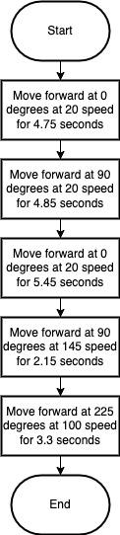

**Block Code**

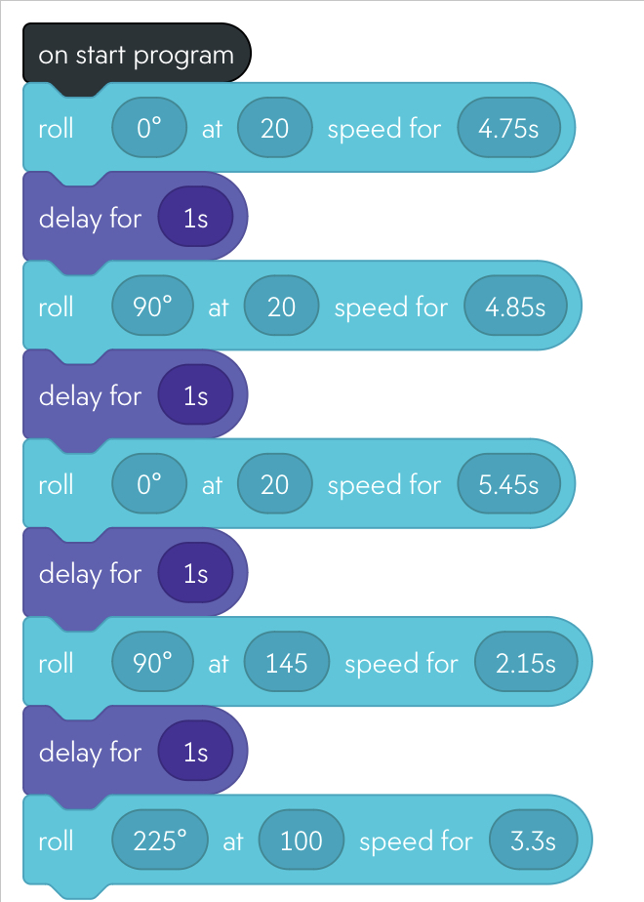

**Sensor Data**

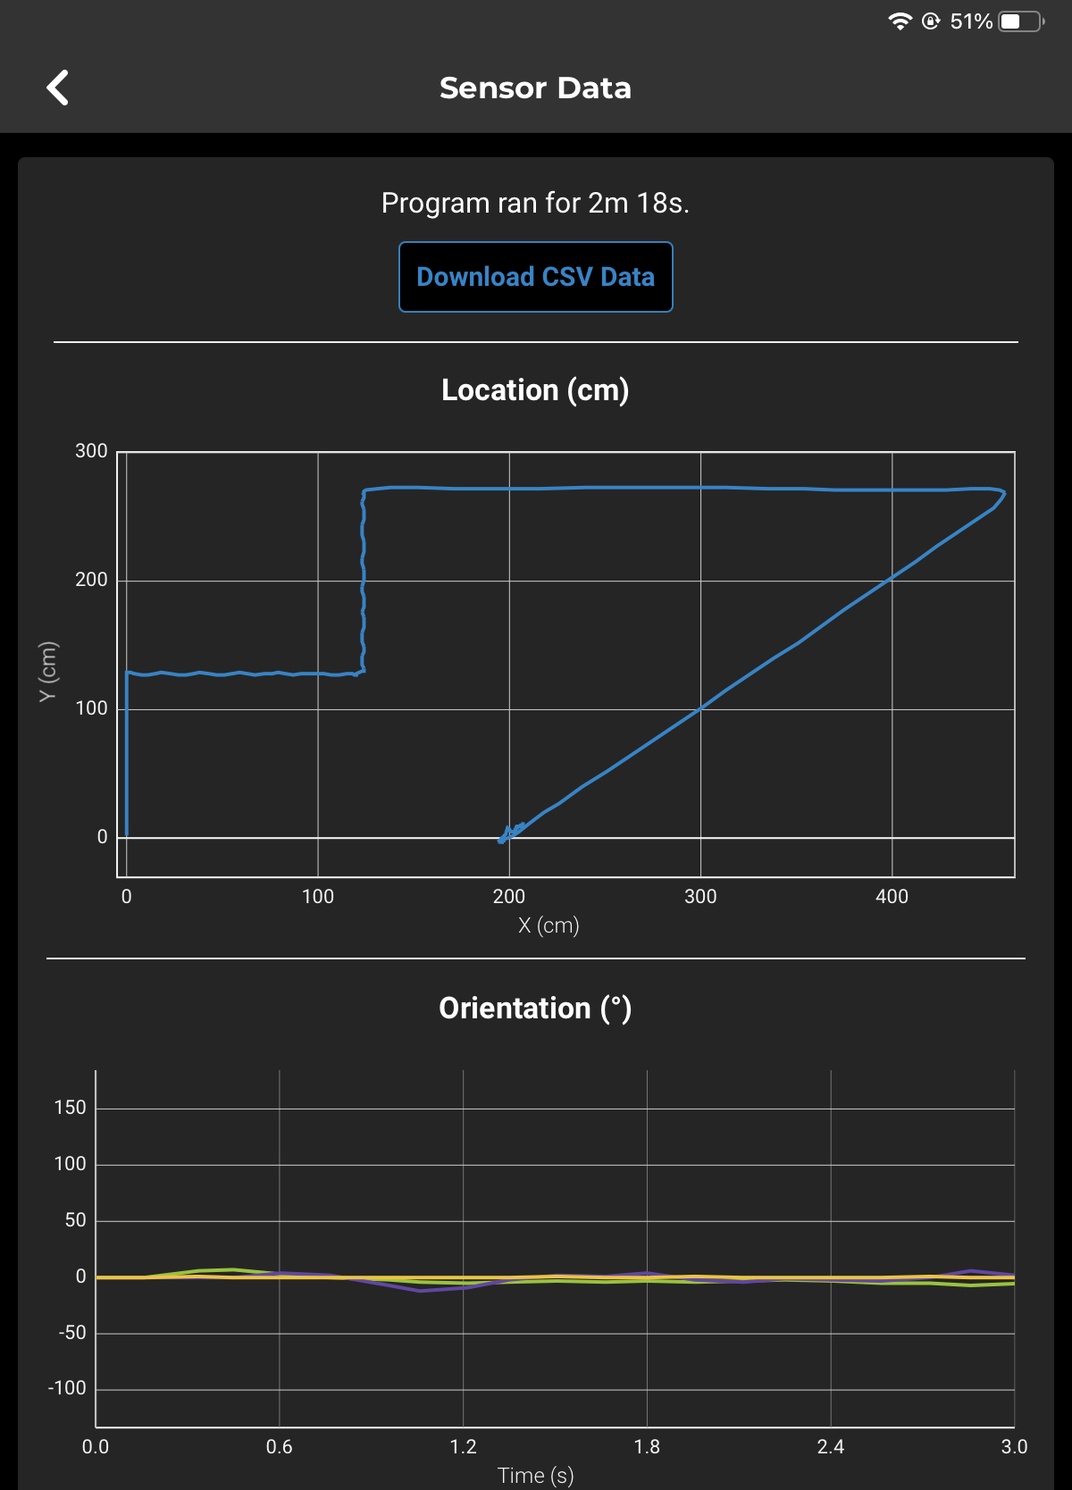

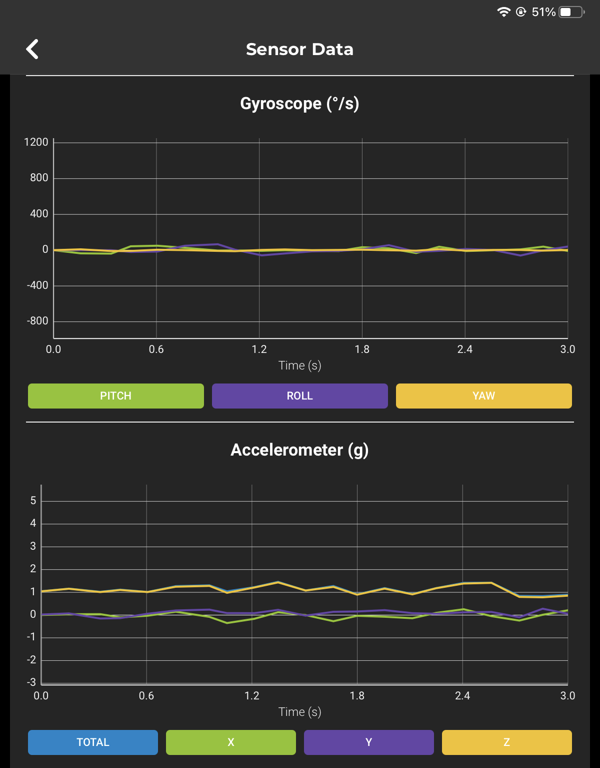

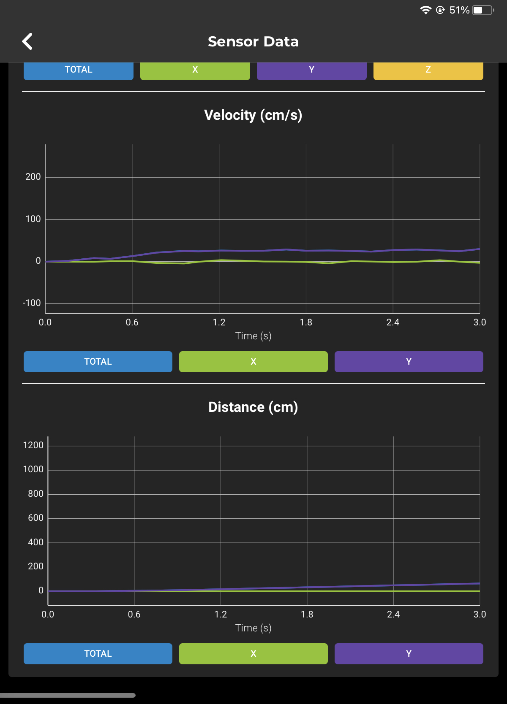

## ***Software***

This application was developed and tested on Sphero Edu, using block code to deploy the application.

## ***Hardware***

To develop, test, and demonstrate this application, the team members used different hardware platforms. These included 2 MacBook Laptops (one from each team member), which helped in the development of the application on the software Sphero Edu; the Sphero SPRK Coding Robot, which was used to test and demonstrate this application on the course outlined on the floor; the charger of the Sphero SPRK Coding Robot, which helped keep the robot powered for the testing process as well as the demonstration.

## ***Test Plan***

| **Reason for Test Case** | **Test Date** | **Expected Output** | **Observed Output** | **Staff Name** | **Pass/Fail** |
| --- | --- | --- | --- | --- | --- |
| Requirement Number(s):  AGI_01 | 04-19-23 | Start the run in the square given |  | Julia Buck | PASS |
| Requirement Number(s):  AGI_02 | 04-19-23 | Does not collide with any objects pre-positioned | Was able to pas the first obstacle, but had a slight encounter with the second | McKayla Mikza | FAIL |
| Requirement Number(s):  AGI_02 | 04-19-23 | Does not collide with any objects pre-positioned | Had a second run-in with the second object | McKayla Mikza | FAIL |
| Requirement Number(s):  AGI_02 | 04-19-23 | Does not collide with any objects pre-positioned |  | McKayla Mikza | PASS |
| Requirement Number(s):  AGI_03 | 04-19-23 | Goes over ramp | Missed the ramp completely and moved to the left of the ramp | Julia Buck | FAIL |
| Requirement Number(s):  AGI_03 | 04-19-23 | Goes over ramp | Missed the ramp completely and moved to the left of the ramp | Julia Buck | FAIL |
| Requirement Number(s):  AGI_03 | 04-19-23 | Goes over ramp | Went up the side of the ramp but still not over | Julia Buck | FAIL |
| Requirement Number(s):  AGI_03 | 04-19-23 | Goes over ramp | Missed the ramp completely and moved to the left of the ramp | Julia Buck | FAIL |
| Requirement Number(s):  AGI_03 | 04-19-23 | Goes over ramp | Went over ramp but continued to roll to long and di dnto make the turn at the appropriate time | Julia Buck | FAIL |
| Requirement Number(s):  AGI_03 | 04-19-23 | Goes over ramp |  | Julia Buck | PASS |
| Requirement Number(s):  AGI_04 | 04-19-23 | Knock over pins |  | McKayla Miksza | PASS |
| Requirement Number(s):  AGI_05 | 04-19-23 | Does not stray from the path given | Robot is programmed ot go slow to avoid strayign from the path | Julia Buck | PASS |

## ***Task List/Gantt Chart***

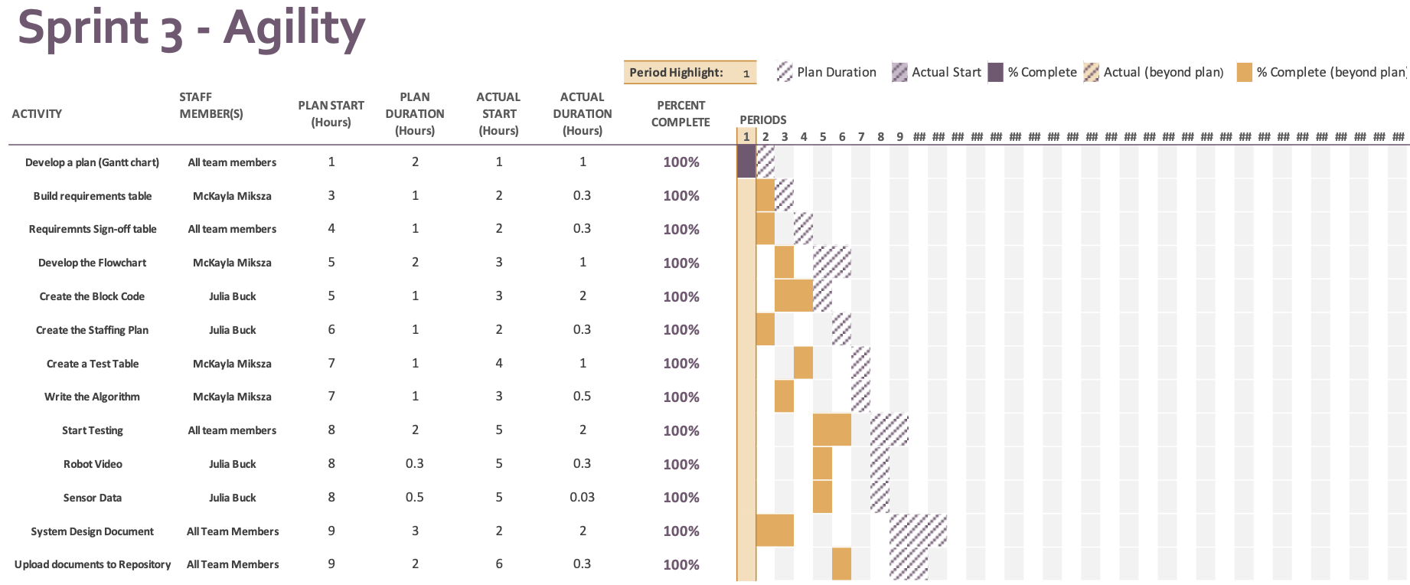

## ***Staffing Plan***

| Name | Role | Responsibility | Reports To |
| --- | --- | --- | --- |
| McKayla Miksza | Team Member | Develop a Plan (Gantt Chart)  Build a Requirements Table  Requirements Sign-off Table.  Build a Flowchart  Create a Test Table  Create the Algorithm  Testing Process  System Design Document  Upload documents to Repository | Julia Buck |
| Julia Buck | Team Member | Develop a Plan (Gantt Chart)  Requirements Sing-off Table.  Create the Block Code  Create the Staffing Plan  Testing Process  Take Robot Course Completion Video  Take Screenshot of Sensor Data  System Design Document  Upload Documents/Video to Repository | McKayla Miksza |